Data Sheets:

**Arduino Mega2560 Rev3**

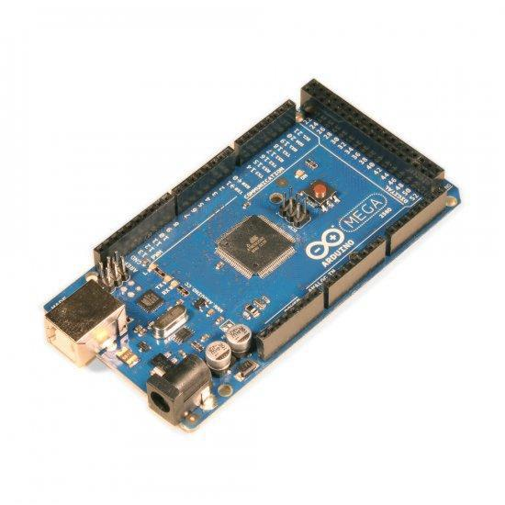

The Arduino Mega 2560 is a microcontroller board based on the ATmega2560. It has 54 digital input/output pins (of which 14 can be used as PWM outputs), 16 analog inputs, 4 UARTs (hardware serial ports), a 16 MHz crystal oscillator, a USB connection, a power jack, an ICSP header, and a reset button. It contains everything needed to support the microcontroller; simply connect it to a computer with a USB cable or power it with a AC-to-DC adapter or battery to get started. The Mega is compatible with most shields designed for the Arduino Uno, Duemilanove or Diecimila.

The Mega 2560 is an update to the [Arduino Mega](http://arduino.cc/en/Main/ArduinoBoardMega), which it replaces.

Additional features coming with the R3 version are:

* ATmega16U2 instead 8U2 as USB-to-Serial converter.
* 1.0 pinout: added SDA and SCL pins for TWI communication placed near to the AREF pin and two other new pins placed near to the RESET pin, the IOREF that allow the shields to adapt to the voltage provided from the board and the second one is a not connected pin, that is reserved for future purposes.
* stronger RESET circuit.

**Technical Specifications**

Microcontroller

Operating Voltage

Input Voltage (recommended)

Input Voltage (limits)

Digital I/O Pins

Analog Input Pins

DC Current per I/O Pin

DC Current for 3.3V Pin

Flash Memory

SRAM

EEPROM

Clock Speed

ATmega2560

5V

7-12V

6-20V

54 (of which 14 provide PWM output)

16

40 mA

50 mA

256 KB of which 8 KB used by bootloader

8 KB

4 KB

16 MHz

**Arduino Nano**

The Arduino Nano is a small, complete, and breadboard-friendly board based on the ATmega328 (Arduino Nano 3.0) or ATmega168 (Arduino Nano 2.x). It has more or less the same functionality of the Arduino Duemilanove, but in a different package. It lacks only a DC power jack, and works with a Mini-B USB cable instead of a standard one. The Nano was designed and is being produced by Gravitech.

|  |  |
| --- | --- |
| Technical Specification |  |
| Microcontroller | Atmel ATmega168 or ATmega328 |
| Operating Voltage (logic | 5 V |
| level) |
|  |
| Input Voltage (recommended) | 7-12 V |
| Input Voltage (limits) | 6-20 V |
| Digital I/O Pins | 14 (of which 6 provide PWM output) |
| Analog Input Pins | 8 |
| DC Current per I/O Pin | 40 mA |
| Flash Memory | 16 KB (ATmega168) or 32 KB (ATmega328) of which 2 KB used by |
| bootloader |
|  |
| SRAM | 1 KB (ATmega168) or 2 KB (ATmega328) |
| EEPROM | 512 bytes (ATmega168) or 1 KB (ATmega328) |
| Clock Speed | 16 MHz |
| Dimensions | 0.73" x 1.70" |

If you want to give a closer look to this board we advice you to visit the official Arduino Nano page in the Hardware Section.

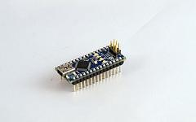

**Bluetooth module HC06**

**INTRODUCTION**

Bluetooth modules are designed for wireless data transmission between small distances it Considered as wireless personal area network technology (WPAN) it works at ultra-high frequencies (UHF). Regarding to industrial, scientific and medical (ISM) radio bands witch governing industrial, scientific and medical frequencies, the Bluetooth range from 2.402 GHZ to 2.480.

It considers as the cheapest method for data transmission, easiest and more flexible compared to other methods. It even can transmit files reach to 25 Mb/s.

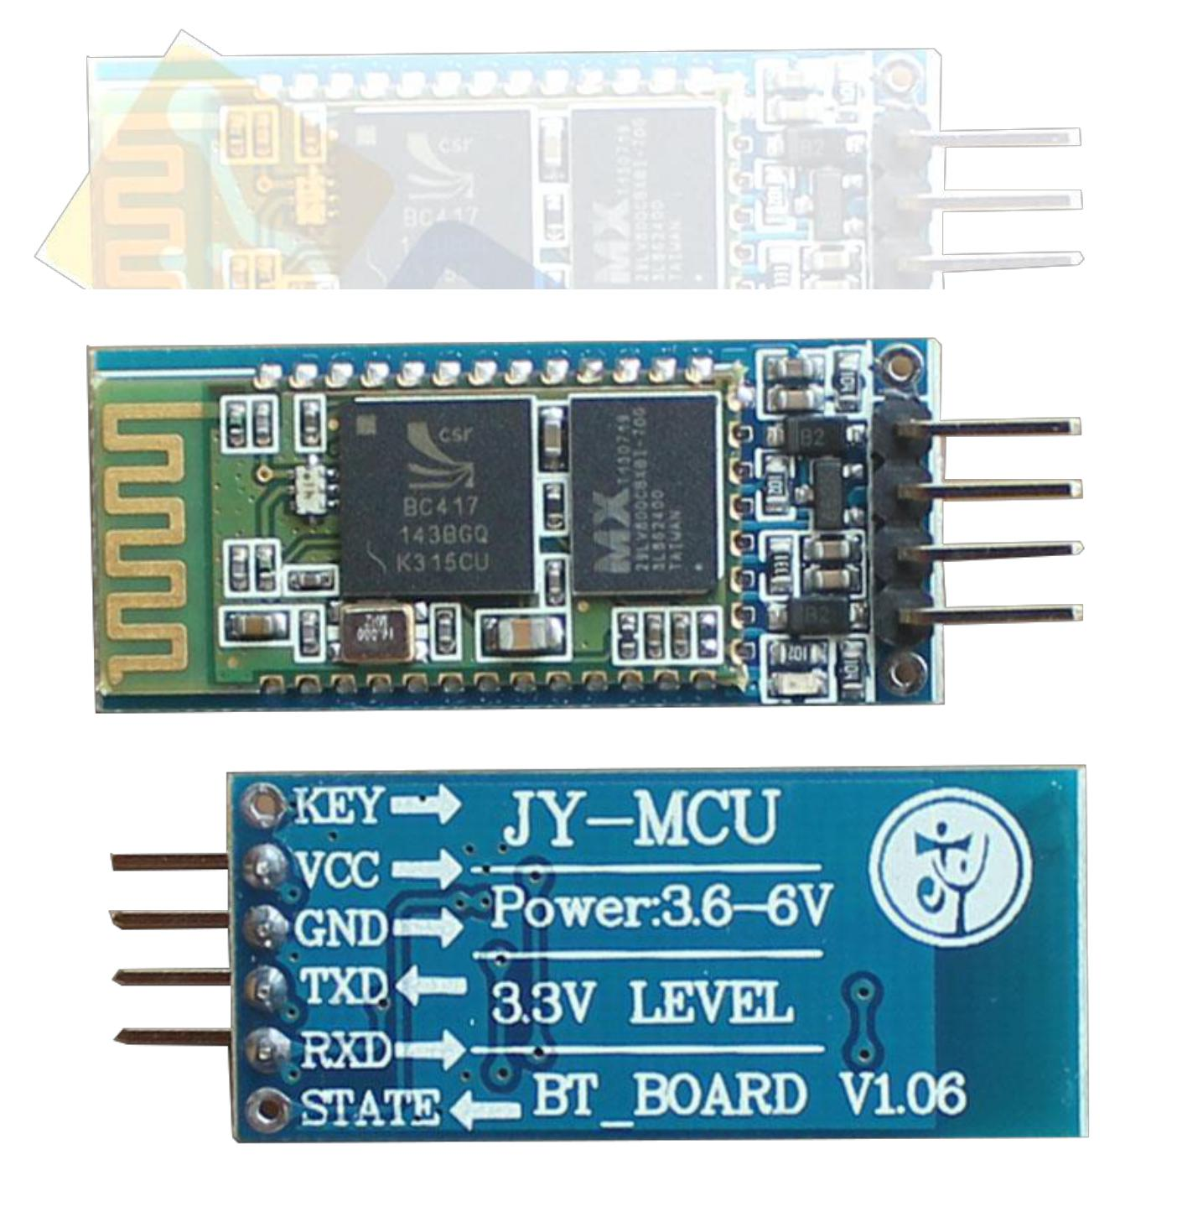This technique depends on frequency hopping spread spectrum technique (FHSS) it use this technique to avoid interference with other devices and it a full duplex transmission which mean it can transmit and receive at same time.

**Bluetooth module HC06 Features**

* Operating voltage: 5 v
* Slave: is a model for a communication protocol in which one device or process known as the master controls one or more other devices or processes known as slaves.
* Enable bin: it can be connected to 5V or left without connecting this allow the module to work but in case of connecting it to ground it doesn’t work.
* Key pin: some modules doesn’t contain this pin so a wire could be welded to it.

This pin has two modes AT mode which allow the user to enter commands to it and connection mode which allow the connection between device

**How Bluetooth connection occurs**

1- The master device sends request to all surrounding Bluetooth modules, all slave modules reply with the 48-bit number which is unique for each Bluetooth device similar to MAC address.

2- when the master determines the slave wants to pair with it starts synchronization process as the master send message with the internal date, time, type of the device, services provided by him and operating frequency these process occurred in base band layer.

3- after that the link manager layer in which Link Management Protocol (LMP) responsible for authentication and authorization process, data Encryption and frequency hopping management.

4- then in the next layer Logical Link Control and Adaptation Protocol (L2CAP) which responsible for data transmission management and data divide into packets.

5- using Service Discovery Protocol (SDP) the master Bluetooth module determines the service provided by the slave (profile) depending on this profile the master determines the type of data to send to this device.

6- finally the paring action occurs when the master device gives the pin number to allow the master to exchange data at any time.

**Piezo Transducer 30vac 0.5-20hz 75db lead type**

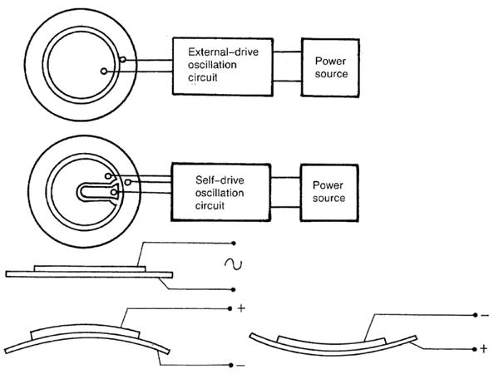

Tone type: piezo speaker

Operating voltage: 30 VAC

Rated voltage: 15 VAC

Current consumption: 1.5 mA

Resonant frequency: 0.5-20 ± 0.5 kHz

Sound pressure level: 75 dB

Connector type: leads

Body color: metal

Weight: 0.11 oz

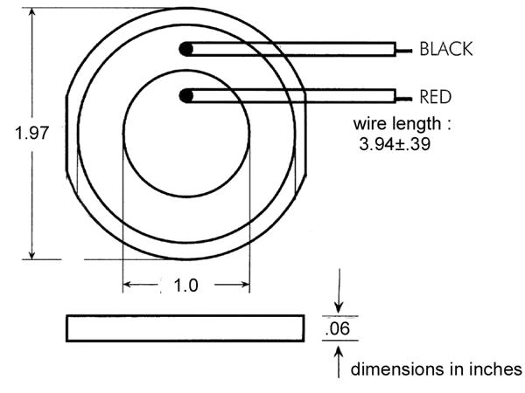

**4x4 Matrix Membrane Keypad (#27899)**

This 16-button keypad provides a useful human interface component for microcontroller projects.

Convenient adhesive backing provides a simple way to mount the keypad in a variety of applications.

**Features**

* Ultra-thin design
* Adhesive backing

•

•

Excellent price/performance ratio Easy interface to any microcontroller

* Example programs provided for the BASIC Stamp 2 and Propeller P8X32A microcontrollers

**Key Specifications**

* Maximum Rating: 24 VDC, 30 mA
* Interface: 8-pin access to 4x4 matrix
* Operating temperature: 32 to 122 °F (0 to 50°C)
* Dimensions:

Keypad, 2.7 x 3.0 in (6.9 x 7.6 cm) Cable: 0.78 x 3.5 in (2.0 x 8.8 cm)

**Application Ideas**

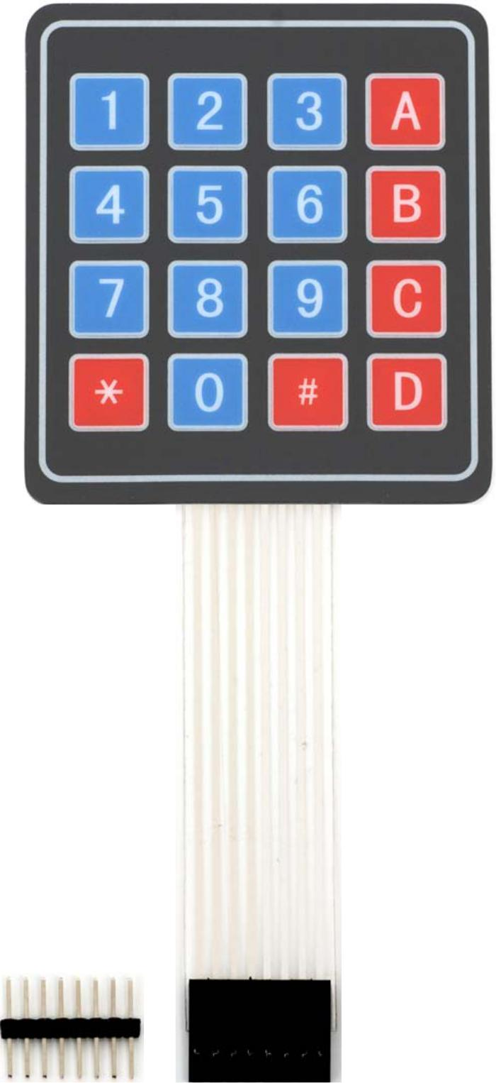

* Security systems
* Menu selection
* Data entry for embedded systems

**How it Works**

Matrix keypads use a combination of four rows and four columns to provide button states to the host device, typically a microcontroller. Underneath each key is a pushbutton, with one end connected to one row, and the other end connected to one column. These connections are shown in Figure 1.

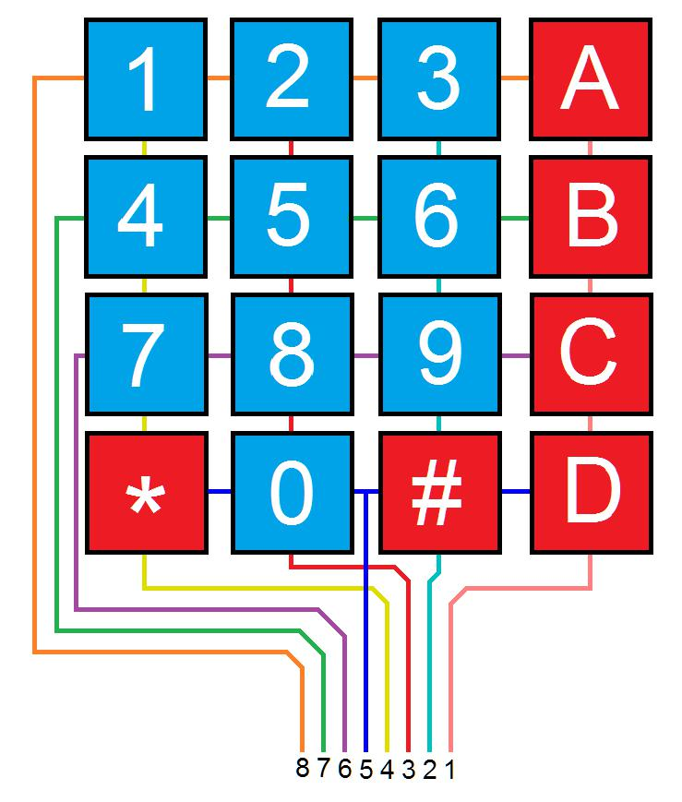

**Figure 1: Matrix Keypad Connections**

In order for the microcontroller to determine which button is pressed, it first needs to pull each of the four columns (pins 1-4) either low or high one at a time, and then poll the states of the four rows (pins 5-8). Depending on the states of the columns, the microcontroller can tell which button is pressed.

For example, say your program pulls all four columns low and then pulls the first row high. It then reads the input states of each column, and reads pin 1 high. This means that a contact has been made between column 4 and row 1, so button ‘A’ has been pressed.

**Connection Diagrams**

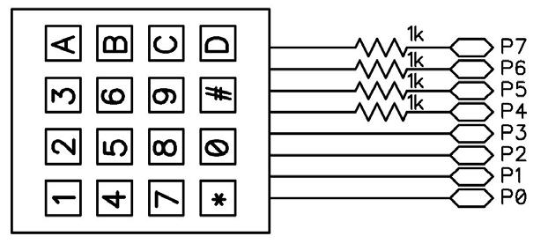**Figure 2**

For use with the BASIC Stamp example program listed below.

**Figure 3**

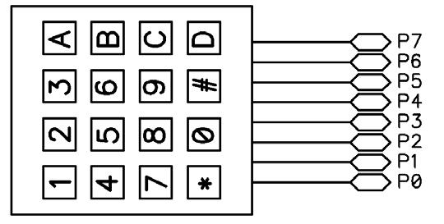

For use with the Propeller P8X32A example program listed below.

**BASIC Stamp® Example Code**

The example code below displays the button states of the 4x4 Matrix Membrane Keypad. It uses the Debug Terminal, which is built into the BASIC Stamp Editor software. The software is a free download from www.parallax.com/basicstampsoftware.

* 4x4MatrixKeypad_Demo.bs2
* Display buttons pressed on the 4x4 Matrix Membrane Keypad
* Author: Parallax HK Engineering
* {$STAMP BS2}
* {$PBASIC 2.5}

|  |  |  |  |  |
| --- | --- | --- | --- | --- |
| row | VAR | Nib |  | ' Variable space for row counting |
| column | VAR | Nib |  | ' Variable space for column counting |
| keypad | VAR | Word |  | ' Variable space to store keypad output |
| keypadOld | VAR | Word |  | ' Variable space to store old keypad output |
| temp | VAR | Nib |  | ' Variable space for polling column states |
| DEBUG CLS |  |  |  | ' Clear Debug Terminal |
| GOSUB Update |  |  |  | ' Display keypad graphic |
| DO |  |  |  | ' Read keypad button states |
| GOSUB ReadKeypad | | |  |
| DEBUG HOME, BIN16 keypad, CR, CR, | | | | ' Display 16-bit keypad value |
|  | BIN4 keypad >> 12,CR, | | | ' Display 1st row 4-bit keypad value |
|  | BIN4 keypad >> 8, CR, | | | ' Display 2nd row 4-bit keypad value |
|  | BIN4 keypad >> 4, CR, | | | ' Display 3rd row 4-bit keypad value |
|  | BIN4 keypad | |  | ' Display 4th row 4-bit keypad value |

IF keypad <> keypadOld THEN ' If different button is pressed,

GOSUB Update ' update the keypad graphic to clear

ENDIF ' old display

IF keypad THEN ' Display button pressed in graphic

GOSUB display

ENDIF

keypadOld = keypad ' Store keypad value in variable keypadOld

LOOP

' -----[ Subroutine - ReadKeypad ]-------------------------------------------------

* Read keypad button states ReadKeypad:

keypad = 0

OUTL = %00000000 DIRL = %00000000

FOR row = 0 TO 3

DIRB = %1111

OUTB = %0000

OUTA = 1 << row

DIRA = 1 << row

temp = 0

FOR column = 0 TO 3

INPUT (column + 4)

temp = temp | (INB & (1 << column)) NEXT

keypad = keypad << 4 | (Temp REV 4) NEXT

RETURN

* Initialize IO
* Set columns (P7-P4) as outputs
* Pull columns low (act as pull down)
* Set rows high one by one
* Reset temp variable to 0
* Set columns as inputs
* Poll column state and store in temp
* Store keypad valu

|  |  |  |  |  |  |  |  |
| --- | --- | --- | --- | --- | --- | --- | --- |
| ' -----[ Subroutine - Update ] | | | | | | ----------------------------------------------------- | |
| ' Graphical depiction of keypad | | | | | | |  |
| Update: |  |  |  |  |  |  |  |
| DEBUG CRSRXY,0,7, | | | | |  |  |  |
| "+--- | +--- | +--- | + | ---+",CR, | |  |  |
| "| | | | | | | | |",CR, | |  |  |
| "+--- | +--- | +--- | + | ---+",CR, | |  |  |
| "| | | | | | | | |",CR, | |  |  |
| "+--- | +--- | +--- | + | ---+",CR, | |  |  |
| "| | | | | | | | |",CR, | |  |  |
| "+--- | +--- | +--- | + | ---+",CR, | |  |  |
| "| | | | | | | | |",CR, | |  |  |
| "+--- | +--- | +--- | + | ---+" |  |  |  |
| RETURN |  |  |  |  |  |  |  |
| ' -----[ Subroutine - Display | | | | | | ]---------------------------------------------------- | |
| ' Display button pressed in keypad graphic | | | | | | |  |
| Display: |  |  |  |  | DEBUG | CRSRXY, 02,08,"1" |  |
| IF KeyPad.BIT15 THEN | | | | |  |
| IF Keypad.BIT14 THEN | | | | | DEBUG | CRSRXY, 06,08,"2" |  |
| IF KeyPad.BIT13 THEN | | | | | DEBUG | CRSRXY, 10,08,"3" |  |
| IF Keypad.BIT12 THEN | | | | | DEBUG | CRSRXY, 14,08,"A" |  |
| IF KeyPad.BIT11 THEN | | | | | DEBUG | CRSRXY, 02,10,"4" |  |
| IF Keypad.BIT10 THEN | | | | | DEBUG | CRSRXY, 06,10,"5" |  |
| IF KeyPad.BIT9 | | |  | THEN | DEBUG | CRSRXY, 10,10,"6" |  |
| IF Keypad.BIT8 | | |  | THEN | DEBUG | CRSRXY, 14,10,"B" |  |
| IF KeyPad.BIT7 | | |  | THEN | DEBUG | CRSRXY, 02,12,"7" |  |
| IF Keypad.BIT6 | | |  | THEN | DEBUG | CRSRXY, 06,12,"8" |  |
| IF KeyPad.BIT5 | | |  | THEN | DEBUG | CRSRXY, 10,12,"9" |  |

IF Keypad.BIT4 THEN DEBUG CRSRXY, 14,12,"C"

IF KeyPad.BIT3 THEN DEBUG CRSRXY, 02,14,"*"

IF Keypad.BIT2 THEN DEBUG CRSRXY, 06,14,"0"

IF KeyPad.BIT1 THEN DEBUG CRSRXY, 10,14,"#"

IF Keypad.BIT0 THEN DEBUG CRSRXY, 14,14,"D"

RETURN

**Propeller™ P8X32A Example Code**

The example code below displays the button states of the 4x4 Matrix Membrane Keypad, and is a modified version of the 4x4 Keypad Reader DEMO object by Beau Schwabe.

Note: This application uses the 4x4 Keypad Reader.spin object. It also uses the Parallax Serial Terminal to display the device output. Both objects and the Parallax Serial Terminal itself are included with the with the Propeller Tool v1.2.7 or higher, which is available from the Downloads link at www.parallax.com/Propeller.

{{ 4x4 Keypad Reader PST.spin

Returns the entire 4x4 keypad matrix into a single WORD variable indicating which buttons are pressed. }}

CON

_clkmode = xtal1 + pll16x

_xinfreq = 5_000_00

OBJ

text : "Parallax Serial Terminal"

KP : "4x4 Keypad Reader"

VAR

word keypad

PUB start

'start term

text.start(115200)

text.str(string(13,"4x4 Keypad Demo..."))

text.position(1, 7)

text.str(string(13,"RAW keypad value 'word'"))

|  |  |  |
| --- | --- | --- |
| text.position(1, 13) |  |  |
| text.str(string(13,"Note: Try pressing | | multiple keys")) |
| repeat |  |  |
| keypad := KP.ReadKeyPad | '<-- One | line command to read the 4x4 keypad |
| text.position(5, 2) |  |  |
| text.bin(keypad>>0, 4) | 'Display | 1st ROW |
| text.position(5,3) |  |  |
| text.bin(keypad>>4, 4) | 'Display | 2nd ROW |
| text.position(5, 4) |  |  |
| text.bin(keypad>>8, 4) | 'Display | 3rd ROW |
| text.position(5, 5) |  |  |
| text.bin(keypad>>12, 4) | 'Display | 4th ROW |
| text.position(5, 9) |  |  |
| text.bin(keypad, 16) | 'Display | RAW keypad value |

**Revision History**

v1.0: original document

v1.1: Updated Figure 1 on page 2

v1.2: Updated Figure 1 on page 2 (again); updated BS2 comments

**4-Channel 5V Relay Module**

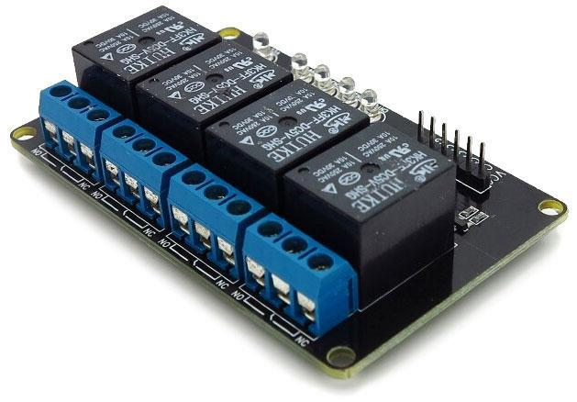

**Description**

**Overview**

This is a 5V 4-Channels Relay module, It can be controlled directly by a wide range of microcontrollers such as Arduino, AVR, PIC, ARM and MSP430.

4 relays are included in this module, with “NC” ports means “Normally connected to COM” and “NO” ports means “Normally open to COM”. This module also equipped with 4 LEDS to show the status of relays.

**Features**

* 4 mechanical relays with status indicator LED
* Both “NC” and “NO” ports for each relay

**Specification**

* Module Type: Control
* Weight: 70.00g
* Board Size: 8 x 4.8 x 2cm
* Version: 1
* Operation Level: Digital 5V
* Power Supply: External 5V

**16 x 2 Character LCD**

**FEATURES**

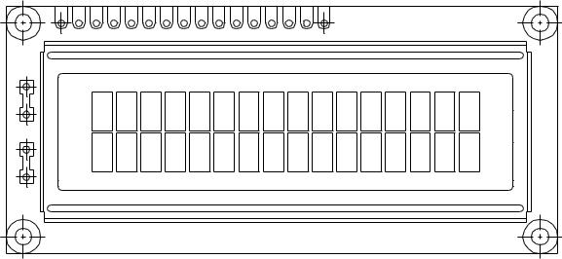

* 5 x 8 dots with cursor
* Built-in controller (KS 0066 or Equivalent)
* + 5V power supply (Also available for + 3V)
* 1/16 duty cycle
* B/L to be driven by pin 1, pin 2 or pin 15, pin 16 or A.K (LED)
* N.V. optional for + 3V power supply

**MECHANICAL DATA**

|  |  |  |  |
| --- | --- | --- | --- |
| **ITEM** | **STANDARD VALUE** | **UNIT** | |
|  |  |  |  |
| Module Dimension | 80.0 x 36.0 | mm | |
|  |  |  |  |
| Viewing Area | 66.0 x 16.0 | mm | |
|  |  |  |  |
| Dot Size | 0.56 x 0.66 | mm | |
|  |  |  |  |
| Character Size | 2.96 x 5.56 | mm | |
|  |  |  |  |

**ABSOLUTE MAXIMUM RATING**

|  |  |  |  |  |  |  |
| --- | --- | --- | --- | --- | --- | --- |
| **ITEM** | **SYMBOL** | **STANDARD VALUE** | | | **UNIT** |  |
|  |  |  |  |  |  |  |
|  |  | **MIN.** | **TYP.** | **MAX.** |  |  |
|  |  |  |  |  |  |  |
| Power Supply | VDD-VSS | - 0.3 | – | 7.0 | V |  |
|  |  |  |  |  |  |  |
| Input Voltage | VI | - 0.3 | – | VDD | V |  |
|  |  |  |  |  |  |  |

**NOTE:** VSS = 0 Volt, VDD = 5.0 Volt

|  |  |  |  |  |  |  |  |  |  |  |  |  |  |  |  |  |  |  |  |  |  |  |  |  |  |  |  |  |  |  |
| --- | --- | --- | --- | --- | --- | --- | --- | --- | --- | --- | --- | --- | --- | --- | --- | --- | --- | --- | --- | --- | --- | --- | --- | --- | --- | --- | --- | --- | --- | --- |
| **ELECTRICAL SPECIFICATIONS** | | | | | | | |  |  |  |  |  |  |  |  |  |  |  |  |  |  |  |  |  |  |  |  |  |  |  |
| **ITEM** | |  | **SYMBOL** | | |  |  |  | **CONDITION** | | | | | | |  |  |  | **STANDARD VALUE** | | | | | | | |  |  | **UNIT** |  |
|  |  |  |  |  |  |  |  |  |  |  |  |  |  |  |  |  |  |  |  |  |  |  | |  |  |  |  |  |  |  |
|  |  |  |  |  |  |  |  |  |  |  |  |  |  |  |  |  |  | **MIN.** |  |  | **TYP.** | | |  |  |  | **MAX.** | |  |  |
|  |  |  |  |  |  |  |  |  |  |  |  | |  | |  |  |  |  |  |  |  |  | |  |  |  |  |  |  |  |
| Input Voltage | |  |  | VDD | |  |  |  | VDD = + 5V | | | | | | |  |  | 4.7 |  |  | 5.0 | | |  |  |  | 5.3 |  | V |  |
|  |  |  |  |  |  |  |  |  |  |  |  | |  | |  |  |  |  |  |  |  |  | |  |  |  |  |  |  |  |
|  |  |  |  |  |  |  |  |  | VDD = + 3V | | | | | | |  |  | 2.7 |  |  | 3.0 | | |  |  |  | 5.3 |  | V |  |
|  |  |  |  |  |  |  |  |  |  |  |  | |  |  |  |  |  |  |  |  |  |  | |  |  |  |  |  |  |  |
| Supply Current | |  |  | IDD | |  |  |  |  | VDD = 5V | | | |  |  |  |  | – |  |  | 1.2 | | |  |  |  | 3.0 |  | mA |  |
|  |  |  |  |  |  |  |  |  |  |  |  | |  |  |  |  |  |  |  |  |  |  |  |  |  |  |  |  |  |  |
|  |  |  |  |  |  |  |  |  |  | - 20 C | | | |  |  |  |  | – |  |  |  |  | – |  |  |  | – | |  |  |
| Recommended LC Driving | | | VDD - V0 | | |  |  |  |  | 0C | |  |  |  |  |  |  | 4.2 |  |  | 4.8 | | |  |  |  | 5.1 |  | V |  |
| Voltage for Normal Temp. | | |  |  |  |  |  |  |  | 25C | |  |  |  |  |  |  | 3.8 |  |  | 4.2 | | |  |  |  | 4.6 |  |  |  |
|  |  |  |  |  |  |  |  |  |  |  |  |  |  |  |  |  |  |  |  |  |  |  | |  |  |  |  |  |  |  |
| Version Module | |  |  |  |  |  |  |  |  | 50C | |  |  |  |  |  |  | 3.6 |  |  | 4.0 | | |  |  |  | 4.4 |  |  |  |
|  |  |  |  |  |  |  |  |  |  |  |  |  |  |  |  |  |  |  |  |  |  |  |  |  |  |  |  |  |  |  |
|  |  |  |  |  |  |  |  |  |  | 70C | |  |  |  |  |  |  | – |  |  |  |  | – |  |  |  | – | |  |  |
| LED Forward Voltage | |  |  | VF | |  |  |  |  | 25C | |  |  |  |  |  |  | – |  |  | 4.2 | | |  |  |  | 4.6 |  | V |  |
| LED Forward Current | |  |  |  | IF |  |  |  |  | 25C | |  |  | Array | |  |  | – |  |  | 130 | | |  |  |  | 260 |  | mA |  |
|  |  |  |  |  |  |  |  |  |  |  |  |  |  |  |  |  |  |  |  |  |  |  | |  |  |  |  |  |  |  |
|  |  |  |  |  |  |  |  |  |  |  |  |  |  | Edge | |  |  | – |  |  | 20 | | |  |  |  | 40 |  |  |  |
|  |  | |  |  |  |  |  |  | |  |  | |  | |  |  |  |  |  |  |  |  |  |  |  |  |  |  |  |  |
| EL Power Supply Current | | |  | IEL | |  |  | Vel = 110VAC:400Hz | | | | | | | |  |  | – |  |  |  |  | – |  |  |  | 5.0 |  | mA |  |
|  |  | |  | |  |  |  |  | |  |  |  |  |  |  |  |  |  |  |  |  |  |  |  |  |  |  |  |  |  |
|  |  | |  | |  |  | |  | |  |  |  |  |  |  |  |  |  |  |  |  |  |  |  |  |  |  |  |  |  |
| **DISPLAY CHARACTER ADDRESS CODE:** | | | | | | | | | | | |  |  |  |  |  |  |  |  |  |  |  |  |  |  |  |  |  |  |  |
| Display Position | | 1 | 2 | 3 | | 4 | | 5 | 6 | |  | 7 |  | 8 | |  | 9 | 10 | 11 | 12 | 13 | | | 14 |  | 15 | 16 |  |  |  |
| DD RAM Address |  |  |  |  |  |  |  |  |
|  | 00 | 01 |  |  |  |  |  |  |  |  |  |  |  |  |  |  |  |  |  |  |  |  |  |  |  | 0F |  |  |  |
|  |  |  |  |  |  |  |  |  |  |  |  |  |  |  |  |  |  |  |  |  |  |  |  |  |  |  |  |
|  |  | |  |  |  |  |  |  |  |  |  |  |  |  |  |  |  |  |  |  |  |  |  |  |  |  |  |  |  |  |
| DD RAM Address | 40 | | 41 |  |  |  |  |  |  |  |  |  |  |  |  |  |  |  |  |  |  |  |  |  |  |  | 4F |  |  |  |
|  |  |  |  |  |  |  |  |  |  |  |  |  |  |  |  |  |  |  |  |  |  |  |  |  |  |  |  |  |  |  |
|  |  |  |  |  |  |  |  |  |  |  |  |  |  |  |  |  |  |  |  |  |  |  |  |  |  |  |  |  |  |  |

**LCD-016M002B**

|  |  |  |  |  |  |  |
| --- | --- | --- | --- | --- | --- | --- |
|  | 16 x 2 Character LCD | | | |  |  |
|  |  |  |  |  |  |  |
| **PIN NUMBER** | **SYMBOL** | | |  | **FUNCTION** | |
|  |  |  |  |  |  |  |
| 1 | Vss | | |  | GND | |
|  |  |  |  |  |  |  |
| 2 | Vdd | | |  | + 3V or + 5V | |
|  |  |  |  |  |  |  |
| 3 | Vo | | |  | Contrast Adjustment | |
|  |  |  |  |  |  |  |
| 4 | RS | | |  | H/L Register Select Signal | |
|  |  |  |  |  |  |  |
|  |  |  |  |  |  | |
| 5 | R/W | | |  | H/L Read/Write Signal | |
|  |  |  |  |  |  |  |
| 6 | E | | |  | H → L Enable Signal |  |
| 7 | DB0 | | |  | H/L Data Bus Line | |
|  |  |  |  |  |  |  |
| 8 | DB1 | | |  | H/L Data Bus Line | |
|  |  |  |  |  |  |  |
| 9 | DB2 | | |  | H/L Data Bus Line | |
|  |  |  |  |  |  |  |
| 10 | DB3 | | |  | H/L Data Bus Line | |
|  |  |  |  |  |  |  |
| 11 | DB4 | | |  | H/L Data Bus Line | |
|  |  |  |  |  |  |  |
| 12 | DB5 | | |  | H/L Data Bus Line | |
|  |  |  |  |  |  |  |
| 13 | DB6 | | |  | H/L Data Bus Line | |
|  |  |  |  |  |  |  |
| 14 | DB7 | | |  | H/L Data Bus Line | |
|  |  |  |  |  |  |  |
| 15 | A/Vee | | |  | + 4.2V for LED/Negative Voltage Output | |
|  |  |  |  |  |  |  |
| 16 | K | | |  | Power Supply for B/L (OV) | |
|  |  |  |  |  |  |  |

**DIMENSIONS** in millimeters

|  |  |  |  |  |  |  |  |  |  |
| --- | --- | --- | --- | --- | --- | --- | --- | --- | --- |
|  |  |  |  |  |  |  |  | **80.0** ± **0.5** |  |
|  |  |  |  | **4.95** | |  |  | **71.2** |  |
|  |  |  |  |  |  | **7.55** |  | **66.0 (VA)** |  |
|  | **25.** | **89.** | **5512.** | **7611.** | **7615.** | **12.45** | **1.8** | **56.2 (AA)** | **52.** |
|  | **3.0** | **16 Ø 1.0 PTH** |
|  |  |  |  |  |  | **8.0** |  | **P2.54* 15 = 38.1** |  |
|  |  |  |  |  |  | **1** |  |  | **16** |
| **0536.0.** |  |  |  |  |  | **K** |  |  |  |
| **225.** | **016.(VA)** | **511.(AA)** | **0813.** | **085.** |  |  |  |  |
|  |  |  |  |  |  | **A** |  |  |  |
|  |  |  | **4 Ø 1.0** | | |  |  | **40.55** |  |
|  |  |  |  |  | **2.5** |  |  | **75.0** |  |

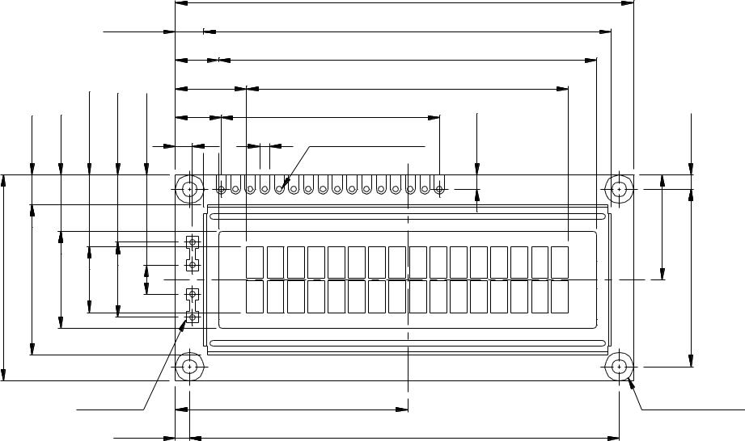

|  |
| --- |
| **2.5** |

|  |
| --- |
| **31.0 18.3** |

**4-Ø 2.5 PTH**

**4-Ø 5.0 PAD**

|  |  |  |
| --- | --- | --- |
|  | **3.55** | **0.6** |
|  | **2.95** |
|  | **0.6** |  |
|  | **0.55** |  |
|  |  | **DOT SIZE** |
| **955.** | **5.550.70.65** |  |
|  | **0.4** |  |
| **H1 MAX** |  | **9.7 MAX** |

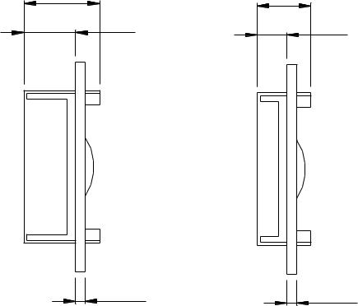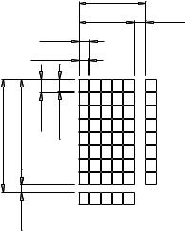

**H2** **5.1**

**1.6** **1.6**

**EL OR NO B/L**

|  |  |  |  |  |  |  |  |  |
| --- | --- | --- | --- | --- | --- | --- | --- | --- |
|  |  |  | **LED - H/L B/L** | | | |  |  |
|  |  |  |  |  | **HIGH** | **LOW** |  |  |
|  |  |  |  | |  |  |  |  |
|  |  |  | H1 | | 13.2 | 12.1 |  |  |
|  |  |  |  | |  |  |  |  |
|  |  |  | H2 | | 8.6 | 7.5 |  |  |
|  |  |  |  |  | | |  |  |
|  |  |  |  |  | | |  |  |
|  |  |  |  |  |  |  |  |  |
|  |  |  |  |  |  |  |  |  |

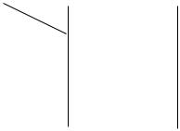

**7-SEGMENT 4 DIGIT CC 14.20MM**

Four digits LED display module, Common Cathode with all decimal points and clock segments, 14 Pins molded case, Epistar LEDs, High Quality, Industrial Grade.

**DIMENSIONS IN MM**

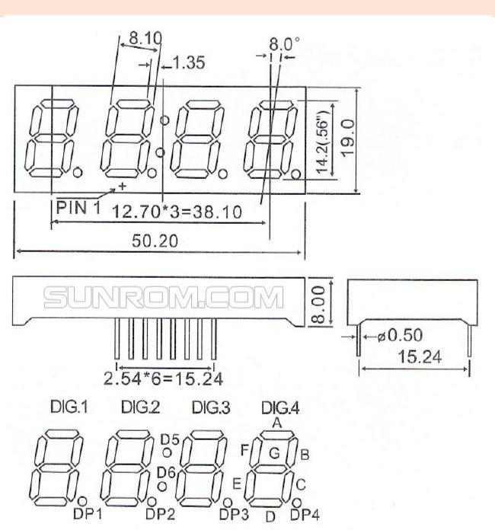

Page **1** of **3**

INTERNAL DIAGRAM

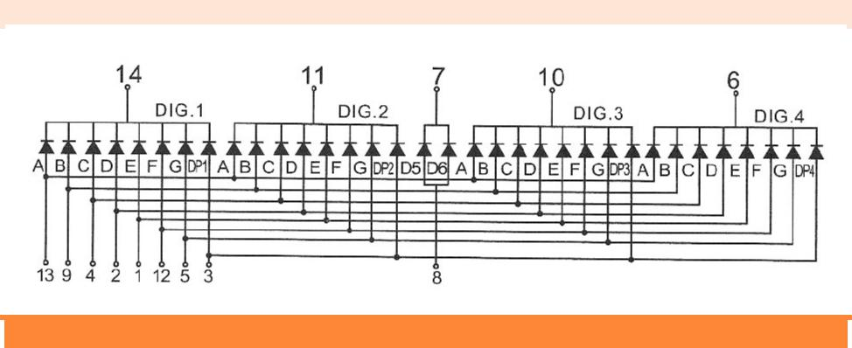

**SPECIFICATIONS**

|  |  |  |  |  |
| --- | --- | --- | --- | --- |
|  |  |  |  |  |
|  | **Product Name** | 4 digit 7 segment display |  |  |
|  | **Digit Height** | 14.2mm (0.56") |  |  |
|  | **Epoxy Color** | Milky White |  |  |
|  | **Digits** | Four |  |  |
|  | **Surface Color** | Black |  |  |
|  | **Pin Configuration** | Common Cathode |  |  |
|  | **Emitting Colors** | Super Red, Super Green, Amber |  |  |

**ABSOLUTE MAXIMUM RATINGS**

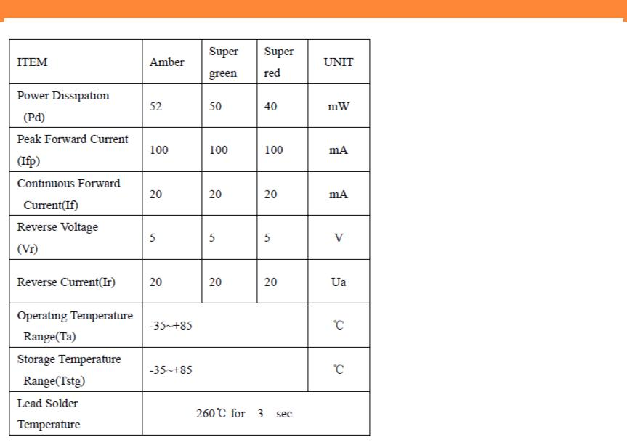

Page **2** of **3**

**COLOR CODE AND CHIP CHARACTERESTICS**

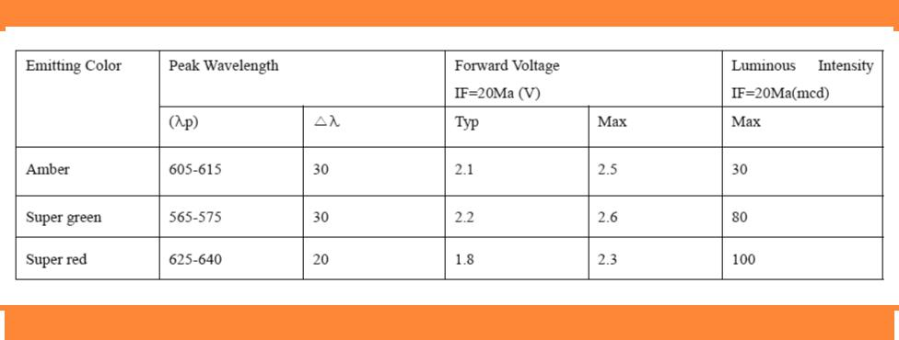

**ORDERING DETAILS**

|  |  |  |  |  |  |  |
| --- | --- | --- | --- | --- | --- | --- |
|  |  |  |  |  |  |  |
|  | **Sunrom Part#** | **Color** | **Ordering Page** | | |  |
|  | **5030** | RED | <http://www.sunrom.com/m/5030> | |  |  |
|  |  |  |  |  |  |  |
|  | **5031** | GREEN | <http://www.sunrom.com/m/5031> | |  |  |
|  |  |  |  |  | |  |
|  | **5032** | AMBER | <http://www.sunrom.com/m/5032> | |  |  |

Samsung wireless charging pad

**Data Sheet** **Wireless Charger** **57911**

|  |  |  |  |  |  |  |
| --- | --- | --- | --- | --- | --- | --- |
| **Type:** | **57911** |  | **Systems to charge:** | | **Mobile device** | |
|  |  |
|  |  |  |  |  |  |  |
| Designation: | **Wireless charger** |  | device: |  | Qi standard | |
|  |  |  |  |  |  |  |
|  |  |  |  |  |  |  |
| **Dimensions:** | **Charger:** |  |  |  |  |  |
|  |  |  |  |  |  |  |
| Diameter: | 98mm |  |  |  |  |  |
|  |  |  |  |  |  |  |
| Height: | 8.5mm w/o rubber feet |  |  |  |  |  |
|  |  |  |  |  |  |  |
| Weight: | 73g |  |  |  |  |  |
|  |  |  |  |  |  |  |
|  |  |  |  |  |  |  |
| **Charging methods:** | **Plug in DC5V Micro USB:** |  |  |  |  |  |
|  |  |  |  |  |  |  |
| Input: | Current: 2000mA |  |  |  |  |  |
|  |  |  | |  |  |  |
| **Output:** | **Wireless for mobile device:** | | |  |  |  |
|  |  |  |  |  |  |  |
| Output: | 5W |  |  |  |  |  |
|  |  |  |  |  |  |  |
|  |  |  |  |  |  |  |
| **Housing:** |  |  | **Indications:** |  |  |  |
|  |  | **LED display** |  |  |  |
|  |  |  |  |  |  |
|  |  |  |  |  | |  |
|  |  | User Display-Status: | | Power on: Breath one time | |  |
|  |  |  |
| Housing Material: | PC and aluminium | Charging: Breath always on(2 seconds for | |  |
| Charging | |  |
|  |  | intensity increasing, 2 seconds of intensity | |  |
|  |  |  |  | decreasing) | |  |
|  |  |  |  | Device fully charged :Constant on | |  |
|  |  |  |  | Standby: off | |  |
|  |  |  |  |  |
|  |  |  |  | Charger base abnormal: Flash(0.4S on, 0.4S | |  |
|  |  |  |  | off) 3 times then off | |  |
|  |  |  |  | Foreign object: Flash(0.4S on, 0.4S off)always | |  |
| Cover colour: | Depending on PO |  |  | on |  |  |
|  |  |  |  | Constant power(less than 1.8A input): Slow | |  |
|  |  |  |  | flash (0.8S on, 0.8S off) | |  |
|  |  |  | |  |  |  |
|  |  |  | |  |  |  |
| **Power In:** | 5V DC 2000mA | **Power Out:** | | 5W |  |  |
|  |  |  |  |  |  |  |
| **Cut off criteria:** | Charger base abnormal |  |  |  |  |  |
|  |  |  |  |  |  |  |
|  | Foreign object |  |  |  |  |  |
|  |  |  |  |  |  |  |
|  | Device fully charged. |  |  |  |  |  |
|  |  |  |  |  |  |  |

12v 7ah Panasonic Battery

